Guidance on maximum Benchmark Timeframes for planning proposals
The NSW Government is committed to reducing the time taken to assess planning proposals. The Department’s categorisation of planning proposals in the Local Environmental Plan Making Guideline (Department of Planning and Environment, August 2023) is supported by category specific timeframes for satisfaction of conditions and authority and Government agency referrals, consultation, and responses.
Compliance with milestones will be monitored by the Department to ensure planning proposals are progressing as required. The Minister may appoint an alternate planning proposal authority if Council does not meet these timeframes.
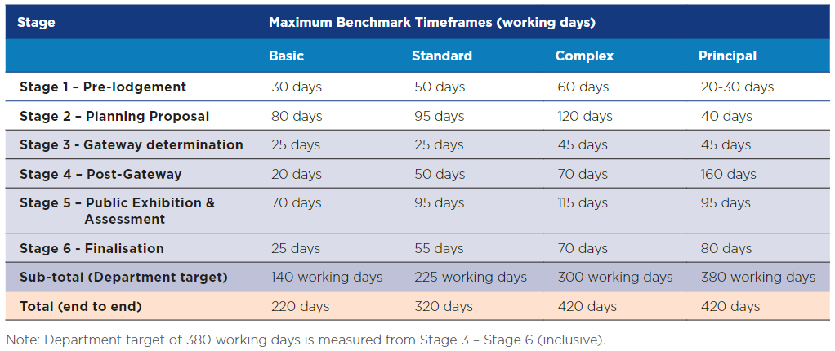
Planning proposal PP-2021-5615 is categorised as a Standard proposal as described in the Local Environmental Plan Making Guidelines (Department of Planning and Environment, August 2023).
To ensure your planning proposal is finalised within 9 months of the gateway determination date and meets the benchmarks timeframes for a Standard proposal we recommend the following milestones:
Community consultation should start: | February 2024
Post exhibition report back to the Panel: | April 2024
Submit for GIS and legal drafting: | June 2024
LEP completion: | Within 9 months of Gateway determination date
Please contact the Department as soon as possible in the event that unexpected delays occur that may impact timing, so that assistance to meet these timeframes can be discussed.

